History
What is unique about the methodology of history? Is eyewitness testimony a reliable source of evidence? How do we decide which events are historically significant?
History is an area of knowledge that studies the recorded past. It raises knowledge questions such as whether it is possible to talk meaningfully about a historical fact and what such a fact might be, or how far we can speak with certainty about anything in the past. Studying history also deepens our understanding of human behavior, as reflecting on the past can help us to make sense of the present.
Documentary evidence plays an important role in history, which raises questions about the basis for judgments of reliability of that evidence. The individual historian also plays an important role in history and in the 20th century there was much debate over whether historical facts exist independently of historians. Some argue that there is always a subjective element in historical writing because historians are influenced by the historical and social environment in which they are writing and this unavoidably affects their selection and interpretation of evidence.
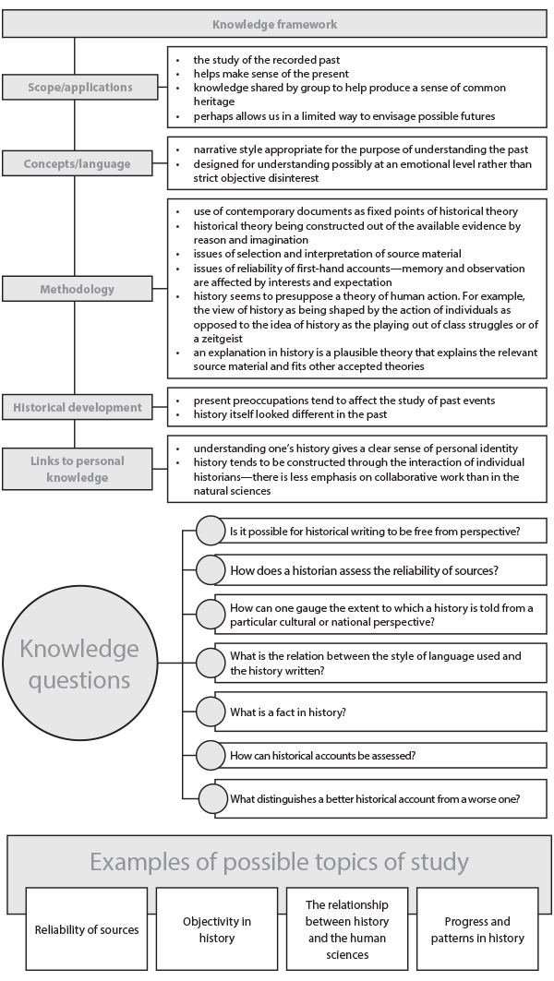
Figure 14

