Test Your Senses Eye Witness Activity
TOK 12
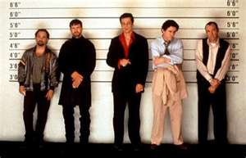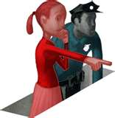
Instructions:
We are going to watch a brief clip on an event. As you watching, use the observation section to take note of what you see. After the clip is finished, flip the sheet over and attempt to answer the questions.

Observations
Eye Witness to Highway Accident Questions

- How many cars were directly involved in the accident?

- What color were the cars?

- Where did the accident take place? Provide as much detail as possible?

- What was the sequence of events that led to the accident? Who is to blame? Provide a step-by-step account of the events.

