Mexico: Geography Based Question
Essential Question: Why is Southern Mexico so plagued with poverty?

Instructions: Answer the questions for each map. Be prepared to write a paragraph as a group that answers the essential question. Be aware, we are making our best guesses at answering these questions. We will use the evidence we have, but it is okay if we can’t answer everything!

Map Set 1: Physical Geography and Climate of Mexico
Mexico’s Climate
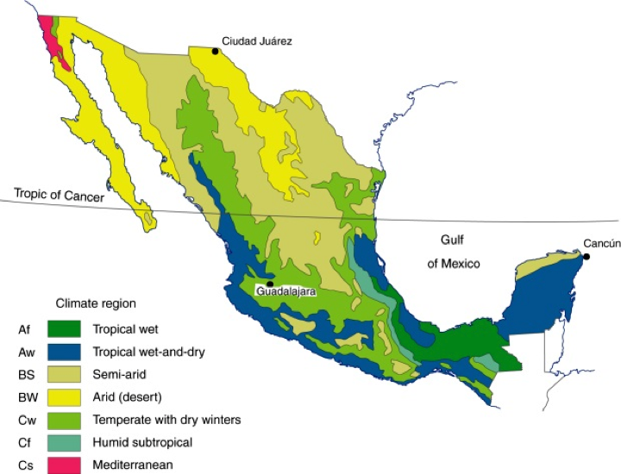
Mexico’s Topography
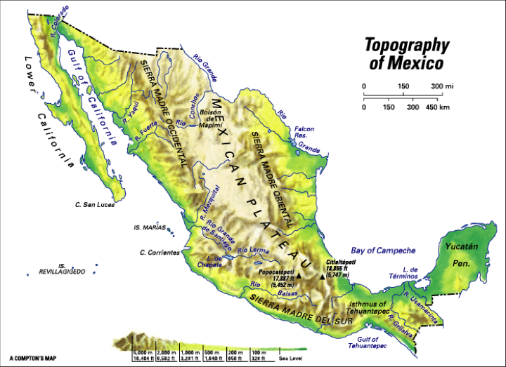
- What is the main difference between north and south Mexico’s climate?

- How might this impact travel and communication in Mexico?

Map Set 2: Political Maps of Mexico
Ancient Civilizations of Mexico
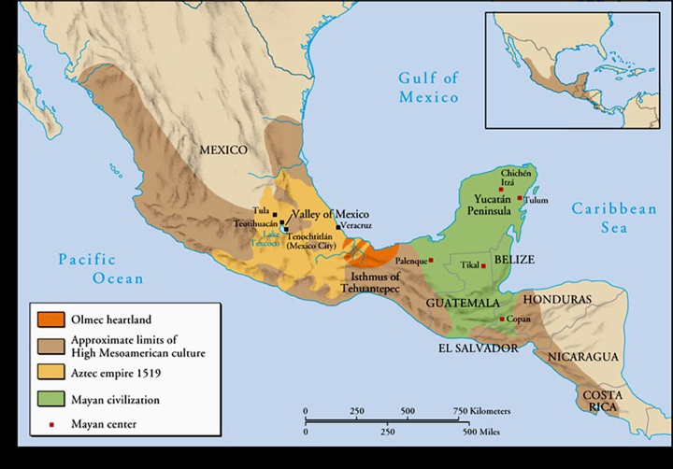

Modern Mexican States
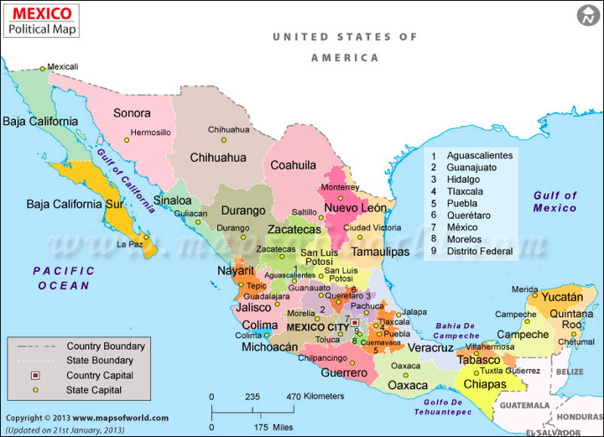

- What parts of Mexico did ancient civilizations mostly occupy?

- Where is the capital of Mexico? Where is this located in regards to the ancient civilizations of Mexico?

- Based on geography and climate of the land, why did these civilizations rise in these parts of Mexico?

Map Set 3: Population Maps
Mexico Population Density Map
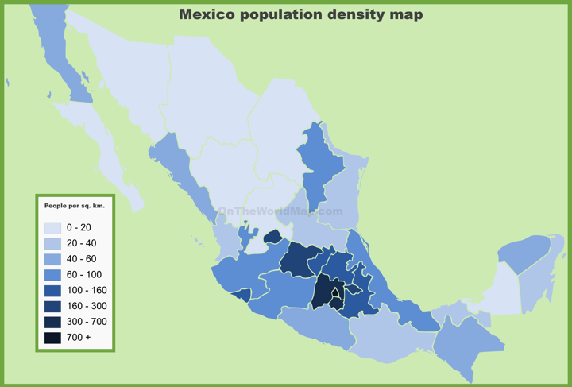
Indigenous (Native) Mexican populations
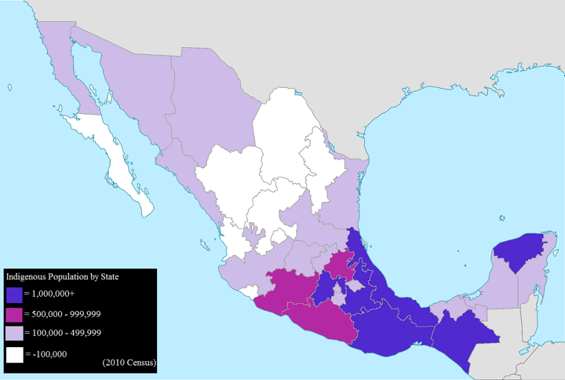
Poverty Rates in Mexico by State
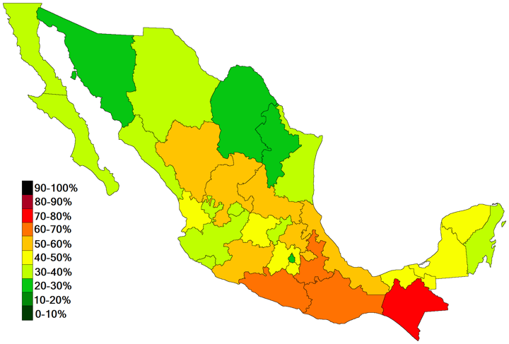
- Where do most people in Mexico live?

- What States are home to the largest number of indigenous populations?

- What states are home to the highest concentration of poverty?

- What conclusions in regards to poverty can we draw based on these maps?

Map Set 4: Natural Resources & Agriculture
Mining & Industry and Agriculture in Modern Mexico
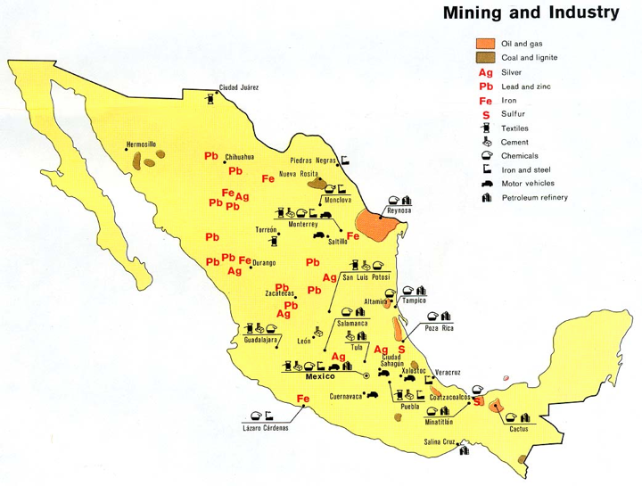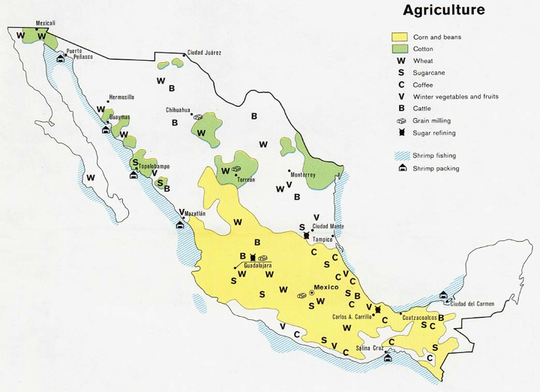

Foreign Car Factories in Modern Mexico
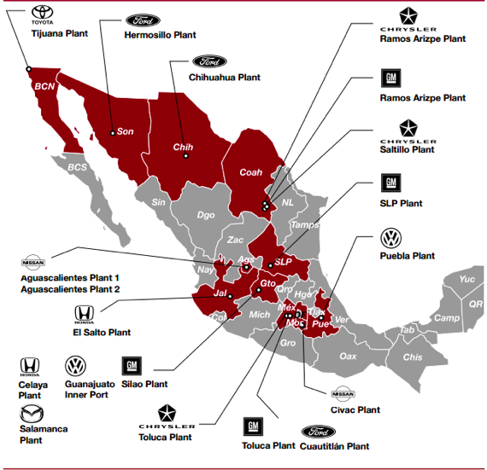
- What are the main differences between the economies of the north and the south?

- How might these maps help explain poverty rates in Mexico?

Now, based on the evidence that you have collected, write a well written paragraph that develops and supports a conclusion about at least two of Mexico’s SPICE elements.

