Instructions: Pick a different color for each of the following countries: Russia, Germany, Poland, Czech Republic. Using the BBC Timeline linked in Lesson 1, color in each map to show the boundaries of each country in the given year. On the back of the worksheet, answer the questions for each timestamp.

1900 | 1920
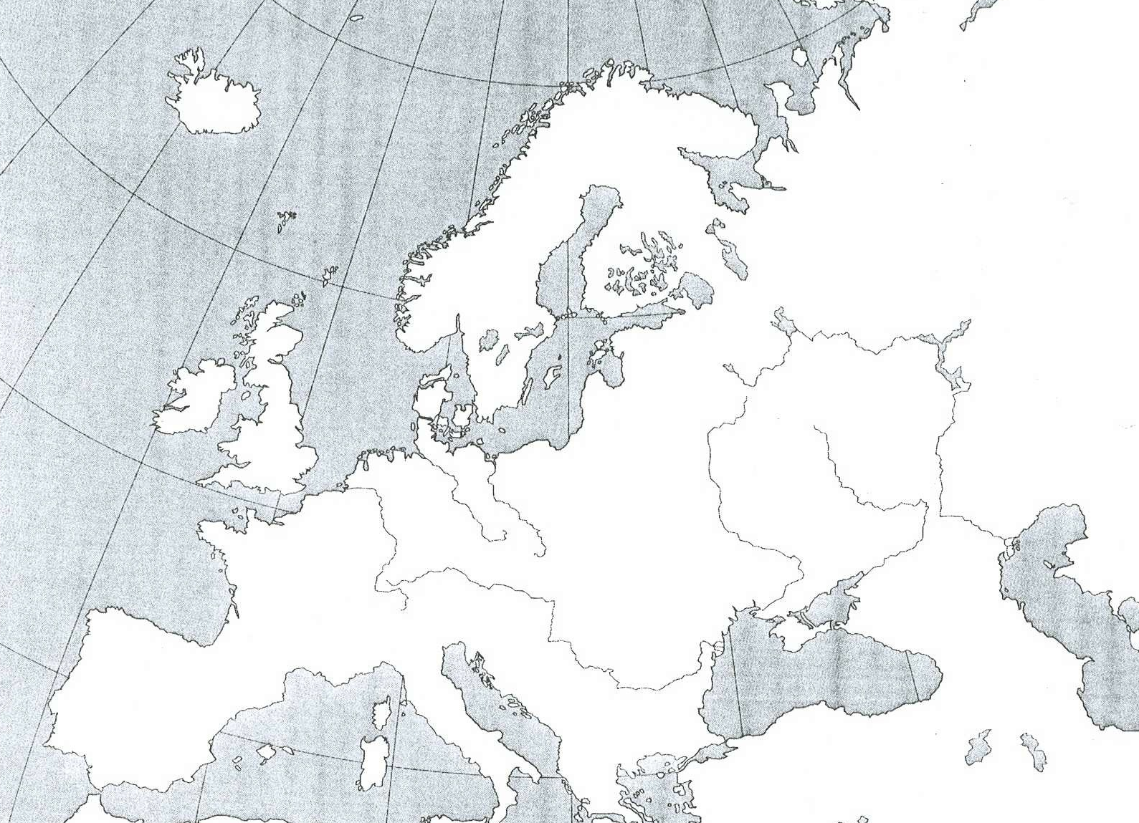
1945 | 1994

1900 | 1920
- What was each of the countries called? | - What was each of the countries called?  - Which countries gained territory?  - Which countries lost territory?
1945 | 1994
- What was each of the countries called?  - Which countries gained territory?  - Which countries lost territory? | - What was each of the countries called?  - Which countries gained territory?  - Which countries lost territory?

- Why have Europe’s borders changed over time?

