Key Term
(Date-Date)

 |  | Summary:
Related Event Before  Year  Description of event | Your Event  Year | Related Event After  Year  Description of event

Key Vocabulary: | Key Individuals:
Comprehension Questions:

Answer Key:

Key Term: (Historical Controversy or Significant Primary Source)
(Date-Date)

Title of Historical Controversy or Significant Primary Source)  Summary/explanation | 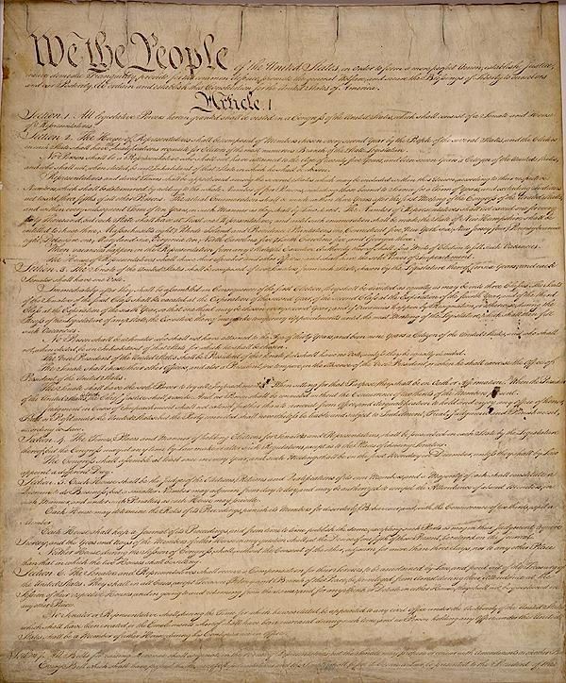
Perspective 1 or  Significance of Primary Source | Perspective 2 or  OPVL for Primary Source
Key Term: Contemporary Art/Artifact or
Short Term and Long Term Consequences

Picture of your art/artifact  OR  Image representing consequences | Contemporary Art/Artifact or  Short Term and Long Term Consequences  Summary
Analysis of Art/Artifact  or  Short Term Consequences | Significance of Art/Artifact  or  Short Term Consequences

