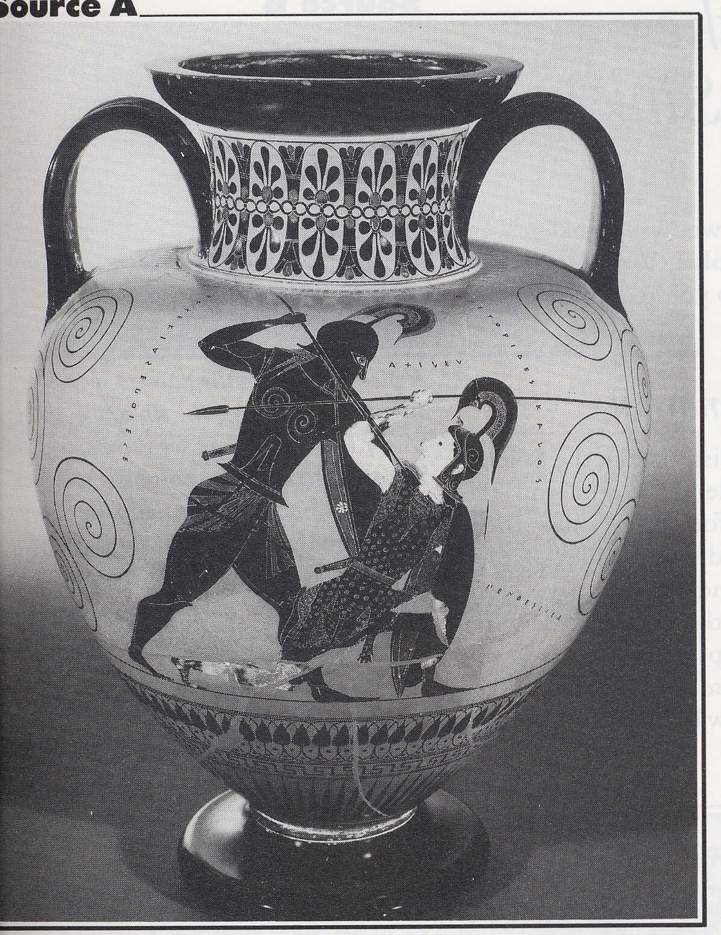
Source A
Picture of an ancient Greek wine jar

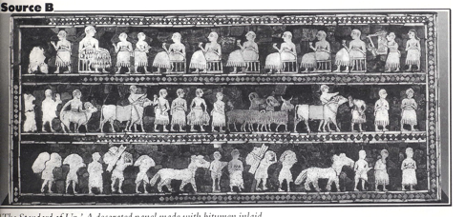
Source B: Decorated panes inlaid with stones. This was found in the ruins of the ancient city of Ur in Iraq and was made about 200 BC

Questions:

What information can you infer about the Ancient Greeks from the wine jar and the Ancient Babylonians from the decorated pane?

How certain can you be about your claims?

