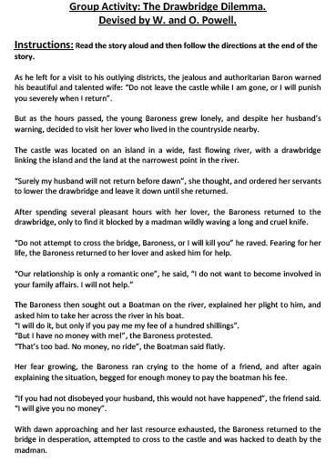
Directions
- Rank the characters in order of immoral behavior in the Round 1 column of the below table. (1:least immoral, 6: most immoral). You have 3 minutes to complete your rankings.
Character | Round 1 | Round 2 | Justification for Ranking
Baron
Baroness
The Lover
The Madman
The Boat Man
The Friend

- Review your rankings in your group in a mini-Socratic discussion. After the discussion (approximately 7 minutes), you have the opportunity to adjust your rankings in the Round Two column. Once your rankings are set, take 10 minutes and provide a 1-sentence justification for your placement of the characters on the morality scale.

- After our class discussion, pair ups with someone who has a different rank order as you. Attempt to articulate your rationale for your morality judgment and listen to your partner’s. In your discussion, explore the below questions in approximately 10 minutes:

  - What is most important in making a moral judgment?

  - Where do these criteria come from?

  - Is your knowledge of them derived from personal knowledge, shared knowledge or some combination of both? Explain the relationship.

- As we feedback to the class, record what you hear from your classmates in the first column of the table on the next page.

Criteria for Moral Judgment | Justification for Moral Criteria | Source of Criteria | Possible Knowledge Question

