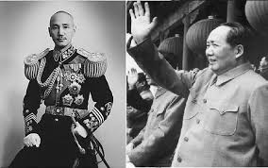Why does China fight a Civil War?

Use the S.P.I.C.E. chart below to take notes on the social, political, environmental, cultural and economic causes of the Chinese Civil War.
S
P
I
C
E

