Knower’s Perspective Sorting Activity “The Odd Man Out”
TOK
Instructions:
Imagine that you are a group of artists. Take ten seconds to internalize your new perspective and then complete the sorting activity below. For each set of images, select the image that does not belong in the group based on the title. Once you have made your selection, please briefly explain your rationale. You have 15 minutes to complete this task.
Flower

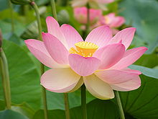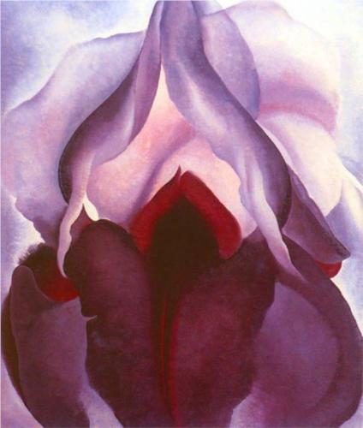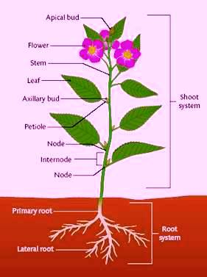
Explanation:

Happiness

Explanation:

Beauty

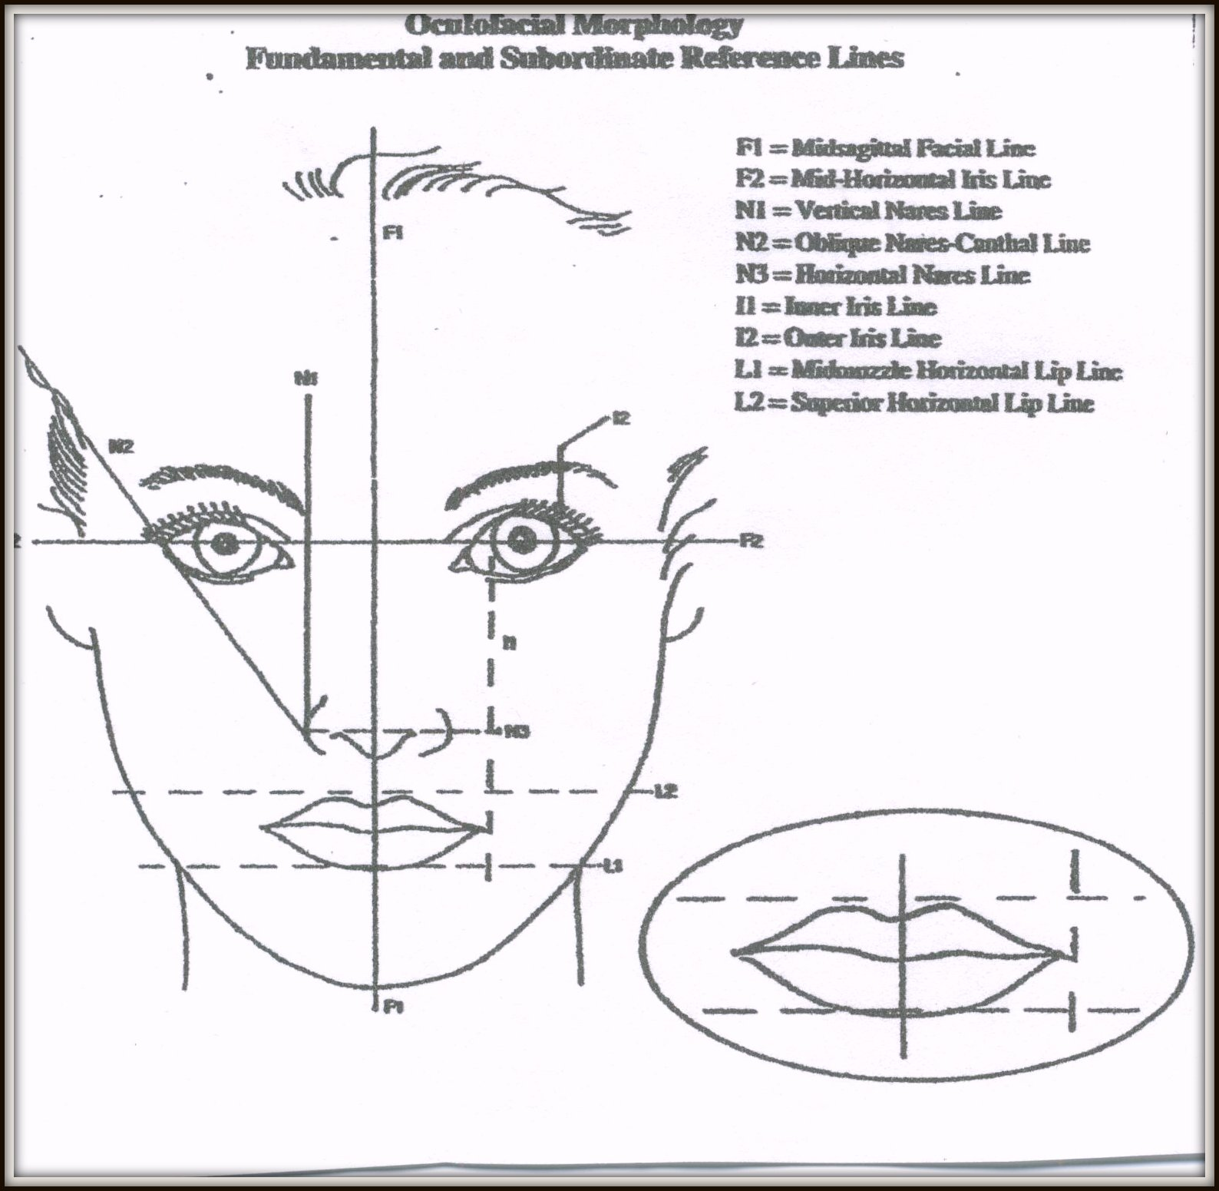

Explanation:
Knower’s Perspective Sorting Activity “The Odd Man Out”
TOK
Instructions:
Imagine that you are a group of historians. Take ten seconds to internalize your new perspective and then complete the sorting activity below. For each set of images, select the image that does not belong in the group based on the title. Once you have made your selection, please briefly explain your rationale. You have 15 minutes to complete this task.
Flower

Explanation:

Happiness

Explanation:

Beauty

Explanation:

Knower’s Perspective Sorting Activity “The Odd Man Out”
TOK
Instructions:
Imagine that you are a group of natural scientists (Chemists, Physicists, and Biologists). Take ten seconds to internalize your new perspective and then complete the sorting activity below. For each set of images, select the image that does not belong in the group based on the title. Once you have made your selection, please briefly explain your rationale. You have 15 minutes to complete this task.
Flower

Explanation:

Happiness

Explanation:

Beauty

Explanation:

