TOK 12
September 28, 2010

Socratic Discussion on Knowledge

Student Name: ________________________________________

CATEGORY | Exemplary (4) | Accomplished (3) | Developing (2) | Basic (1)
Creation of Sound Arguments | Clearly states premises within a sophisticated, rational and logical argument | Presents basic premises within a clear, rational and logical argument | Sometimes presents premises for an argument. Some elements of the arguments were unclear | Arguments were unclear and lacked a logical structure
Use of Evidence | Every major point was well supported with several relevant facts, statistics and/or examples. | Every major point was adequately supported with relevant facts, statistics and/or examples. | Every major point was supported with facts, statistics and/or examples, but the relevance of some was questionable. | Every point was not supported.
Adherence to the Rules | Actively engages in Socratic Discussion and fully adheres to the established format | Engages in the Socratic Discussion and adheres to the format of the discussion | Some input was provided but structures of discussion were not adhered to. | Does not participate in the discussion.
Peer Participation and Engagement | Systematically engages others into the discussion through questions, comments and selection to ensure all gain understanding | Attempts to engage others into the discussion through questions, comments and selection | Limited engagement of others was evident. | Makes no attempt to engage others
Total Score |  | Comments:
Socratic Seminar Peer Evaluation Form Name of Evaluator:
TOK 12 Student Assessed:
Instructions: Use the below form to assess your assigned student. Make sure that you take notes to justify your assessment and provide a summary of those points in your comments section. Remember that in addition to assessment, you are also responsible for developing further discussion questions if the inner circle discussion falters.
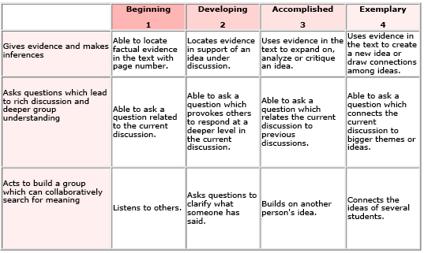
Overall Performance | Supporting Evidence/Comments

